**Week 6 Solutions**

**React**

1. **ReactJS-HOL** .

My Academy team at Cognizant want to create a dashboard containing the details of ongoing and completed cohorts. A react application is created which displays the detail of the cohorts using react component

The code and the folder structure is attached in the **Week 6/5 reactjs HOL/** **coohorttracker** folder

**Output :-**

**Chrome – http://localhost:3000/**

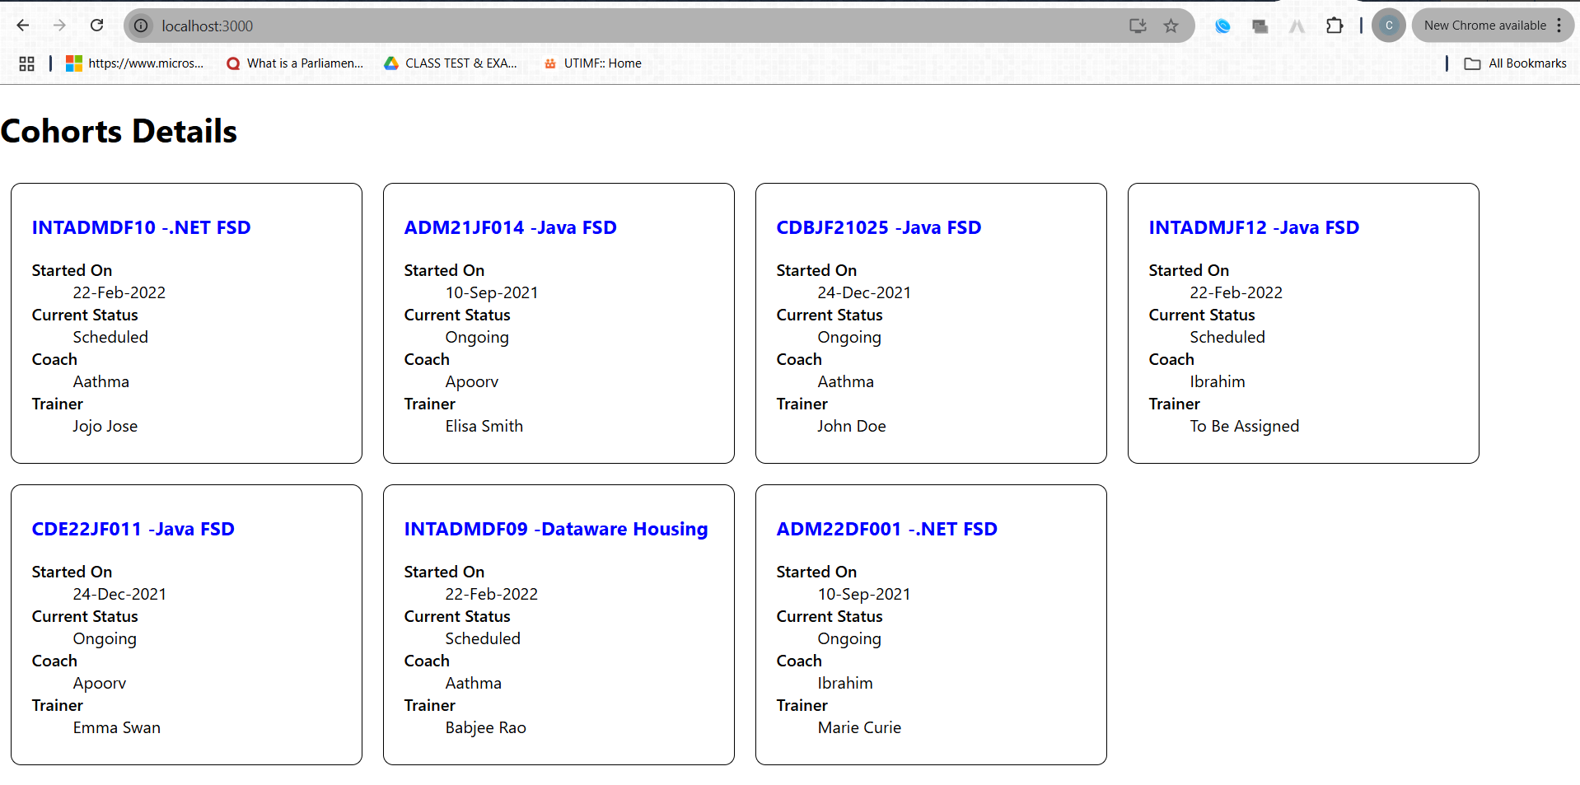

**The hands on file and folder is attached along with it**